**IBM Data Science Capstone Project – Car Accident Severity**

**Introduction & Busines Understanding:**

Car collision are quite common around the world. They cost countries billions of dollars in healthcare cost and property damage and result on thousands of deaths and injuries. To reduce the number of car collision and its severity, a model will be developed to predict the severity of an accident given attributes like weather conditions, car speed, light conditions, and road conditions and several other attributes.

For the data source of this project, I will be using the data from the City of Seattle’s police department showing all the car collisions from 2004 to 2020. This model can be used in an application to warn drivers to be more cautious when driving in bad weather and bad road conditions. This model can also be used by city planners to better design roads and to install warning signs and speed bumps in dangerous road intersections.

**Data Understanding:**

The dataset provided by the City of Seattle’s police department had a total of 194,673 collisions from 2004 to 2020. The dataset has 38 attributes describing the details of each car collision including the severity, coordinates, the number of vehicles, date & time, weather & road conditions for each collision. The figures below highlight the initial analysis made on the used dataset.

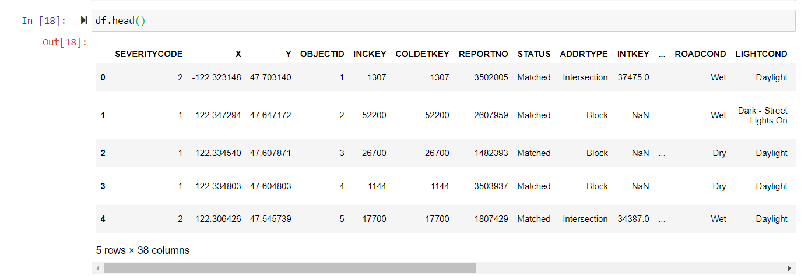

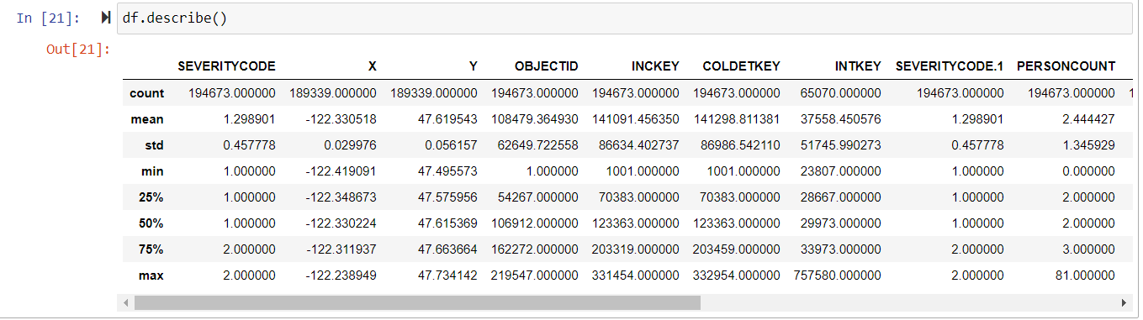

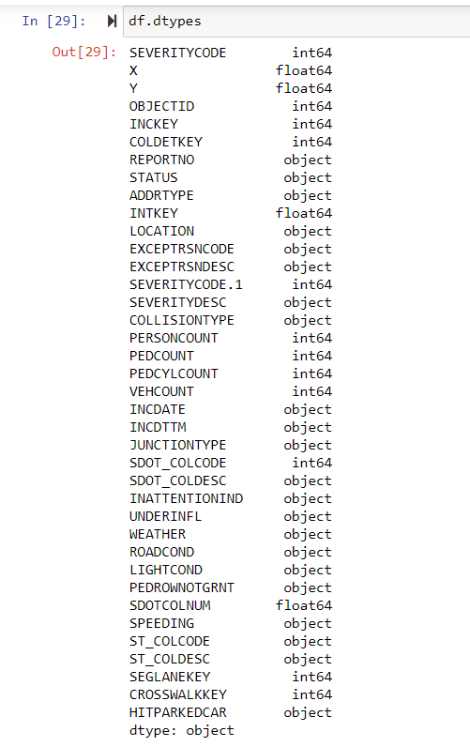

In our model, I will be using (SEVERITYCODE: a code that corresponds to the severity of the collision) as our dependent variable (Y), which will be the target attribute to be predicted**.** As for theindependent variables (X), I will be using the following attributes:

* ADDTYPE: Collision address type (Alley, Block, Intersection)
* WEATHER: A description of the weather conditions during the time of the collision
* ROADCOND: The condition of the road during the collision.
* VEHCOUNT: The number of vehicles involved in the collision. This is entered by the state.
* PERSONCOUNT: The total number of people involved in the collision
* COLLISIONTYPE: Collision type
* LIGHTCOND: The light conditions during the collision.

**Data Preparations:**

**Modeling:**

**Evaluation:**

**Deployment:**